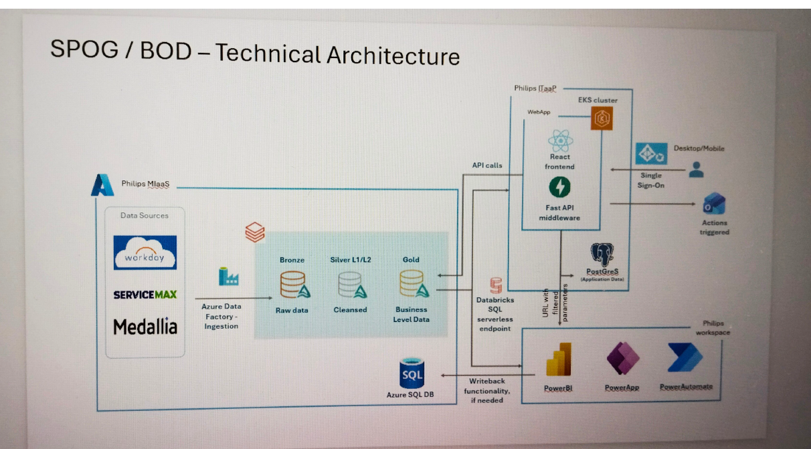

Source Systems
"The source systems are the applications where our business data is generated. In our project, we have three main source systems: Workday, ServiceMax, and Medallia."
- Workday – Stores employee and organizational data, such as engineer details, department, manager, and business unit.
- ServiceMax – Stores service-related data, such as cases, work orders, equipment details, and repair information. Most of our operational KPIs are calculated using this data.
- Medallia – Stores customer feedback and survey responses, which are used to calculate customer experience KPIs like NPS.

Workday → Employee Data
ServiceMax → Service & Work Order Data
Medallia → Customer Feedback Data
↓
Azure Data Factory collects data from all three systems
↓
Databricks processes the data
↓
Dashboard displays the KPIs

Azure Data Factory
"Azure Data Factory is the data integration and orchestration service in our project. It collects data from different source systems and loads it into Databricks for processing."
Main Responsibilities
- Data Ingestion – Reads data from source systems like Workday, ServiceMax, and Medallia.
- Pipeline Orchestration – Controls the execution

Databricks Lakehouse

"After Azure Data Factory loads the data, it is stored and processed in Databricks using the Medallion Architecture. The Medallion Architecture organizes the data into three layers: Bronze, Silver, and Gold."
1. Bronze Layer (Raw Data)
- Stores the data exactly as it comes from the source systems.
- No transformations are applied.
- Used as the raw backup of source data.
Example: If ServiceMax sends 10,000 records, all 10,000 records are stored in the bronze layer without any changes.

2. Silver Layer (Cleansed Data)
- Data is cleaned and validated.
- Removes duplicates.
- Handles null values.
- Standardizes data formats.
- Joins data from multiple source systems.
Example: Duplicate work orders are removed, missing values are handled, and employee details from Workday are joined with ServiceMax data.

3. Gold Layer (Business-Level Curated Data)
- Contains business-ready data.
- Business rules and KPI calculations are applied.
- Used for reporting and dashboards.
Example: KPIs like First Visit Fix, Utilization, NPS, and Equipment Uptime are calculated here and exposed through Gold views.

Databricks SQL Serverless Endpoint
"The Databricks SQL Serverless Endpoint is the query layer of our project. It allows applications to execute SQL queries on the Gold layer data without directly accessing the underlying tables."

Why do we use it?
- Executes SQL queries on Databricks.
- Provides fast, serverless query performance (no cluster management).
- Returns only the required data to applications.

Philips IDaaP (Application Layer)
"Philips IDaaP is the application layer where users interact with the dashboard. It receives user requests, fetches data from Databricks, and displays the results."

Components

1. React Frontend
- This is the user interface (UI).
- Users log in and view dashboards, KPIs, charts, and reports.
Example: When you open the SPOG dashboard in your browser, you're using the React application.

2. Fast API Middleware
- Acts as the bridge between the frontend and Databricks.
- Receives requests from the React application.
- Executes SQL queries on the Databricks SQL Serverless Endpoint.
- Returns the results to the frontend.
Example: If a user clicks on the "First Visit Fix" KPI, Fast API fetches the required data from Databricks and sends it back to the dashboard.

3. EKS Cluster
- EKS (Elastic Kubernetes Service) hosts the React and FastAPI applications.
- It ensures the application is highly available and scalable.
You can simply say:
"The application is deployed in an EKS cluster, which manages and scales the application automatically."

4. PostgreSQL
- Stores application-related data, not business data.
- Used for:
  - User preferences
  - Dashboard configuration
  - Application settings
  - Metadata
  - Audit information
It does not store the KPI or operational data—that remains in Databricks.

- Acts as a secure layer between the dashboard and the data.

Azure SQL Database
Used for:
- Write-back functionality (when required)
- Storing application-specific data that needs updates from the dashboard

Power Platform
The Databricks SQL endpoint also serves:
- Power BI
- Power Apps
- Power Automate
These tools are part of the Philips Workspace.

API Calls
The React application calls the Fast API service.
Fast API sends SQL queries to the Databricks SQL Serverless Endpoint.
The endpoint returns the KPI results.

